**Define roles and rules in Power BI Desktop**

You can define roles and rules within Power BI Desktop. When you publish to Power BI, it also publishes the role definitions.

To define security roles, follow these steps.

1. Import data into your Power BI Desktop report, or configure a DirectQuery connection.

**Note**

You can't define roles within Power BI Desktop for Analysis Services live connections. You need to do that within the Analysis Services model.

1. From the **Modeling** tab, select **Manage Roles**.

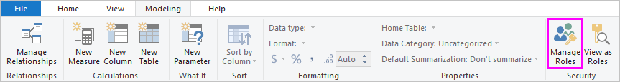

1. From the **Manage roles** window, select **Create**.

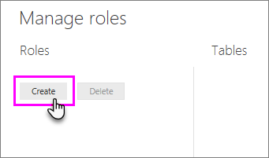

1. Under **Roles**, provide a name for the role.
2. Under **Tables**, select the table to which you want to apply a DAX rule.
3. In the **Table filter DAX expression** box, enter the DAX expressions. This expression returns a value of true or false. For example: [Entity ID] = “Value”.

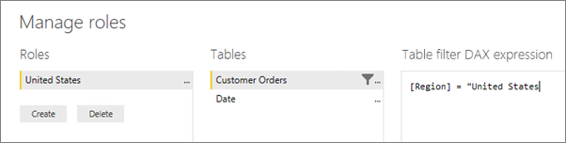

**Note**

You can use *username()* within this expression. Be aware that *username()* has the format of *DOMAIN\username* within Power BI Desktop. Within the Power BI service and Power BI Report Server, it's in the format of the user's User Principal Name (UPN). Alternatively, you can use *userprincipalname()*, which always returns the user in the format of their user principal name, *username@contoso.com*.

1. After you've created the DAX expression, select the checkmark above the expression box to validate the expression.

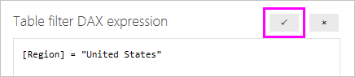

**Note**

In this expression box, you use commas to separate DAX function arguments even if you're using a locale that normally uses semicolon separators (e.g. French or German).

1. Select **Save**.

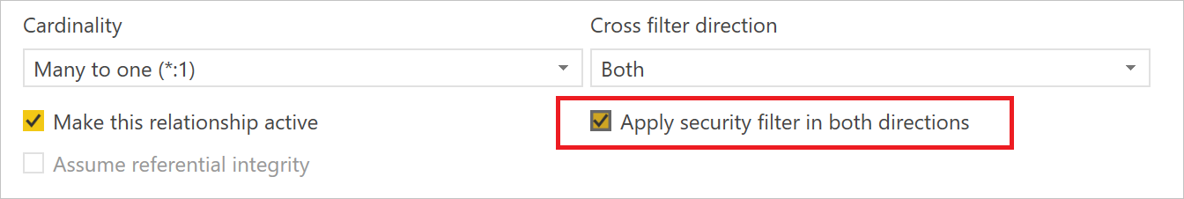

By default, row-level security filtering uses single-directional filters, regardless of whether the relationships are set to single direction or bi-directional. You can manually enable bi-directional cross-filter with row-level security by selecting the relationship and checking the **Apply security filter in both directions** checkbox

## Validate the roles within Power BI Desktop

After you've created your roles, test the results of the roles within Power BI Desktop.

1. From the **Modeling** tab, select **View as Roles**.

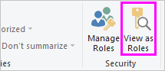

The **View as roles** window appears, where you see the roles you've created.

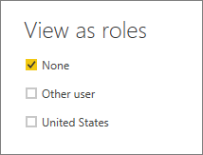

1. Select a role you created, and then select **OK** to apply that role.

The report renders the data relevant for that role.

1. You can also select **Other user** and supply a given user.

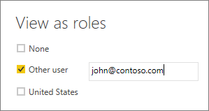

It's best to supply the User Principal Name (UPN) as that's what the Power BI service and Power BI Report Server use.

Within Power BI Desktop, **Other user** displays different results only if you're using dynamic security based on your DAX expressions.

1. Select **OK**.

## Manage security on your model

To manage security on your data model, you will want to do the following.

1. Select the **ellipse (…)** for a dataset.
2. Select **Security**.

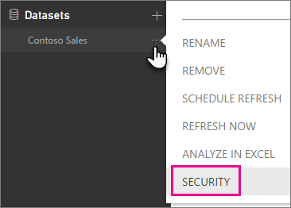

This will take you to the RLS page for you to add members to a role you created in Power BI Desktop. Only the owners of the dataset will see Security available. If the dataset is in a Group, only Administrators of the group will see the security option.

You can only create or modify roles within Power BI Desktop.

## Working with members

### Add members

You can add a member to the role by typing in the email address, or name, of the user, security group or distribution list you want to add. You cannot add Groups created within Power BI. You can add members [external to your organization](https://docs.microsoft.com/en-us/power-bi/guidance/whitepaper-azure-b2b-power-bi#data-security-for-external-partners).

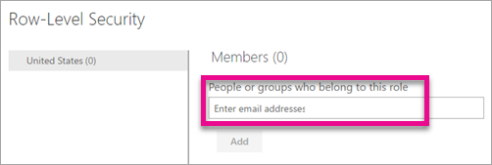

You can also see how many members are part of the role by the number in parenthesis next to the role name, or next to Members.

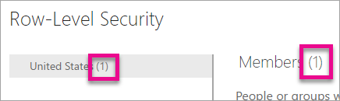

### Remove members

You can remove members by selecting the X next to their name.

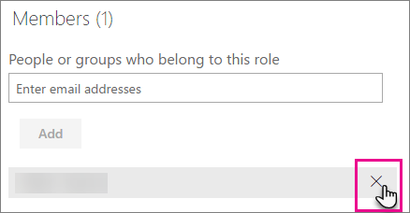

## Validating the role within the Power BI service

You can validate that the role you defined is working correctly by testing the role.

1. Select **More options** (...) next to the role.
2. Select **Test data as role**

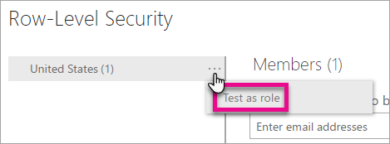

You will then see reports that are available for this role. Dashboards are not presented in this view. In the blue bar above, you will see what is being applied.

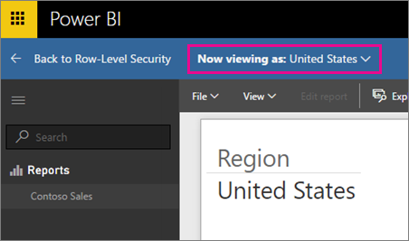

You can test other roles, or combination of roles, by selecting **Now viewing as**.

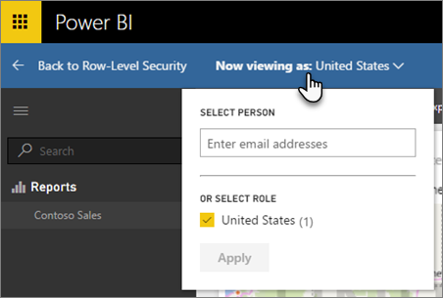

You can choose to view data as a specific person, or you can select a combination of available roles to validate they are working.

To return to normal viewing, select **Back to Row-Level Security**.